5.1 Introduction
System design is the most important phase in the system development life cycle. There is a common saying that well begin is the half done. So nothing is more difficult than to design a new system. System Design presents specific information for the design of the output, input, processing, data structures and database
This chapter describes the designing of the system
5.2 Designing Approaches
Design methods and strategies are tools for the designer. The common design methods are:
- Top down Designing
- Bottom up Designing
The method adopted in designing a new system is known as “Structured Design Approach”. It is viewed as Top down Approach. The structured methodology is based on a building of a logical model of the system.
5.3 Structured Tools
There are two structured tools:
- Data Flow Diagram (DFD) : DFD provides a complete, clean and global understanding of the system
- Data Dictionary (DD): Every system has a large number of data items. In order to maintain these items, a central repository of information about all these data items is maintained for future reference or maintenance purposes or etc. This repository of information is called data dictionary
5.4 Design Specification
System designing consists of the following three steps
- Output designing
- Input designing
- File designing

5.4.1 Output Designing
Output from the system can be in the form of Queries and Reports. Some features which are to be considered while designing output are:
- What output information does the user need?
- What format and volume it should have?
- Output should be good-looking and easy to understand.
- Unnecessary information should be avoided.
5.4.2 Input Designing
Designing of input mainly involves the form designing. Since input plays an important role in data entry phase, so forms have been very carefully and precisely designed.
5.4.3 File Designing
File designing has a fundamental significance in any efficient computerized system. File should be designed in such as way so that you can easily navigate and access to any material or contents you want. Program coding should be easier to maintain and debug and the end-user can also access data and information, reports in an eggicient way and in amount of time.
5.5 Data Normalization
The purpose of the normalization is to produce a stable set of relations that is a faithful model of the operations of the enterprise. There are different forms or level of normalization. It’s up to requirements that how much normalized data you want. Usually normalization is carried up to third normal form. I also normalized my tables up to third normal form.
First Normal Form
A relation is in first normal form if and only if every attribute is single valued for each tipple. This means that each attribute in each row contain only one value. Repeating groups are not allowed
Second Normal Form
A relation is in 2NF if and only if it is the first form and all non-key attributes are fully functionally dependent on the primary key.

Third Normal Form
A relation is in 3NF if and only if it is in 2NF and non-key attribute is transitively dependent on the key.

Normalized Data Base Tables
Data Base Table Name: Category Details
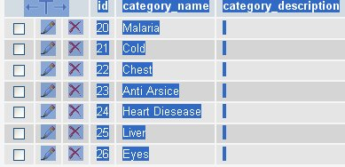

Data Base Table Name Category Details

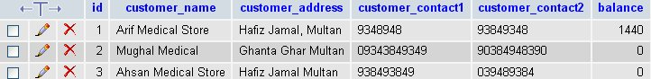

Data Base Table Name Stock Available
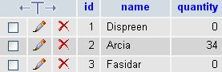
Data Base Table Name Stock Details
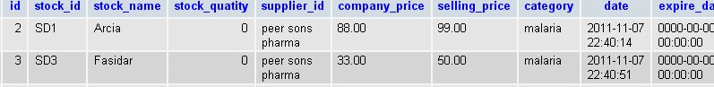
Data Base Table Name Stock Entries
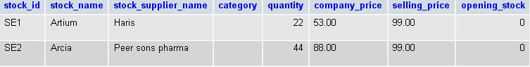
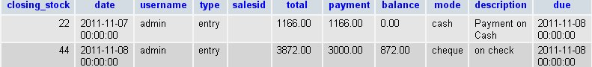
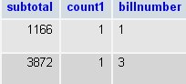
Data Base Table Name Stock Sales
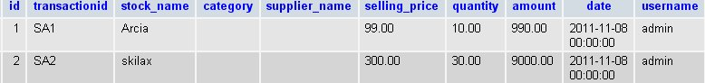
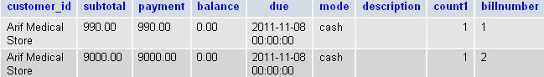

Data Base Table Name Stock User
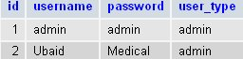
Data Base Table Name Supplier Details
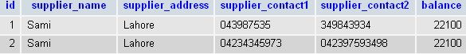

Data Base Table Name Transactions

